
Experiment No. 8
Title: Fog Architecture
Aim: Design and deploy a fog computing architecture using simulators such as iFogSim

Theory:

1. Introduction
The integration of IoT with cloud computing brings many advantages to different IoT applications. However, as there are a large number of IoT devices with heterogeneous platforms, the development of new IoT applications is a difficult task. This is because IoT applications generate huge amounts of data from sensors and other devices. These big data are subsequently analyzed to determine decisions regarding various actions. Sending all these data to the cloud requires excessively high network bandwidth.To overcome these issues, fog computing comes into play.
The term fog computing was coined by Cisco. It is a new technology that provides many benefits to different fields, especially the IoT. Similar to the cloud, fog computing provides services to IoT users such as data processing and storage. Fog computing is based on providing data processing capabilities and storage locally to fog devices instead of sending them to the cloud. Both the cloud and fog provide storage, computing and networking resources.
The purpose of fog computing in the IoT is to improve efficiency, performance and reduce the amount of data transferred to the cloud for processing, analysis and storage. Therefore, the data collected by sensors will be sent to network edge devices for processing and temporary storage, instead of sending them into the cloud, thus reducing network traffic and latency.
The integration of fog computing with the IoT creates a new opportunity for services, which is called fog as a service (FaaS), where a service provider builds an array of fog nodes across its geographic footprint and acts as a landlord to many tenants from many vertical markets. Each fog node hosts local computation, networking and storage capabilities. FaaS will enable new business models to deliver services to customers. Unlike clouds, which are mostly operated by large companies who can afford to build and operate huge data centers, FaaS will enable big and small companies to deploy and operate private or public computing, storage and control services at different scales to meet the needs of a wide variety of customers.

2. Challenges of the Cloud of Things
The integration of the cloud with the IoT, known as CoT, has many benefits. For instance, it helps to manage IoT resources and provides more cost-effective and efficient IoT services. In addition, it simplifies the flow of the IoT data and processing and provides quick, low-cost installation and integration for complex data processing and deployment.
The CoT paradigm is not straightforward, it also introduces new challenges to the IoT system that cannot be addressed by the traditional centralized cloud computing architecture, such as latency, capacity constraints, resource-constrained devices, network failure with intermittent connectivity and enhanced security.
In addition, the centralized cloud approach is not appropriate for IoT applications where operations are time-sensitive, or Internet connectivity is poor. There are many scenarios where milliseconds can have serious significance, such as telemedicine and patient care. This is the same scenario for vehicle-to-vehicle communications, where avoiding collisions or accidents cannot tolerate the latency caused by the centralized cloud approach. Therefore, an advanced cloud computing paradigm that improves the capacity and latency constraints is required to handle these challenges. Cisco suggested new technology called fog computing to address most of these challenges.

3. Fog Computing
3.1. Definition of Fog Computing
Fog computing is a paradigm with limited capabilities such as computing, storing and networking services in a distributed manner between different end devices and classic cloud computing. It provides a good solution for IoT applications that are latency-sensitive.
Although the term was originally coined by Cisco, fog computing has been defined by many researchers and organizations from a number of different perspectives. Yi et al.have provided a general definition of fog computing. It is stated as; “Fog Computing is a geographically distributed computing architecture with a resource pool which consists of one or more ubiquitously connected heterogeneous devices (including edge devices) at the edge of network and not exclusively seamlessly backed by Cloud services, to collaboratively provide elastic computation, storage and communication (and many other new services and tasks) in isolated environments to a large scale of clients in proximity”. Whilst, Vaquero and RoderoMerino defined fog computing as; “a scenario where a huge number of heterogeneous (wireless and sometimes autonomous) ubiquitous and decentralized devices communicate and potentially cooperate among them and with the network to perform storage and processing tasks without the intervention of third parties. These tasks can be for supporting basic network functions or new services and applications that run in a sandboxed environment. Users leasing part of their devices to host these services get incentives for doing so”.
Fog computing is also defined by the OpenFog Consortium as; “a system-level horizontal architecture that distributes resources and services of computing, storage, control and networking anywhere along the continuum from Cloud to Things”.

3.2. Characteristics of Fog Computing
Essentially, fog computing is an extension of the cloud but closer to the things that work with IoT data. As shown in Figure 1, fog computing acts as an intermediary between the cloud and end devices which brings processing, storage and networking services closer to the end devices themselves. These devices are called fog nodes. They can be deployed anywhere with a network connection. Any device with computing, storage and network connectivity can be a fog node, such as industrial controllers, switches, routers, embedded servers and video surveillance cameras.
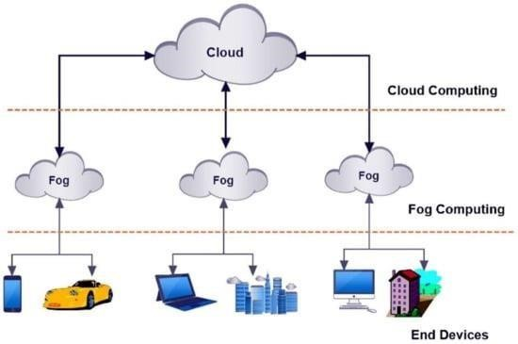
Figure 1. Fog computing is an extension of the cloud but closer to end devices.
Fog computing is considered to be the building blocks of the cloud.
- Location awareness and low latency: Fog computing supports location awareness in which fog nodes can be deployed in different locations. In addition, as the fog is closer to end devices, it provides lower latency when processing the data of end devices.
- Geographical distribution: In contrast to the centralized cloud, the services and applications provided by the fog are distributed and can be deployed anywhere.
- Scalability: There are large-scale sensor networks which monitor the surrounding environment. The fog provides distributed computing and storage resources which can work with such largescale end devices.
- Support for mobility: One of the important aspects of fog applications is the ability to connect directly to mobile devices and therefore enable mobility methods, such as locator ID separation protocol (LISP) which needs a distributed directory system.
- Real-time interactions: Fog computing applications provide real-time interactions between fog nodes rather than the batch processing employed in the cloud.
- Heterogeneity: Fog nodes or end devices are designed by different manufacturers and thus come in different forms and need to be deployed according to their platforms. The fog has the ability to work on different platforms.
- Interoperability: Fog components can interoperate and work with different domains and across different service providers.
Support for on-line analytics and interplay with the cloud: The fog is placed between the cloud and end devices to play an important role in the absorption and processing of the data close to end devices.

3.3. Benefits of Fog Computing
Fog computing expands the cloud computing model to the edge of the network. Although the fog and the cloud use similar resources (networking, computing and storage) and share many of the same mechanisms and attributes (virtualization, multi-tenancy), fog computing brings many benefits for IoT devices.These benefits can be summarized as follows:
Greater business agility: With the use of the right tools, fog computing applications can be quickly developed and deployed. In addition, these applications can program the machine to work according to the customer needs.
Low latency: The fog has the ability to support real-time services (e.g., gaming, video streaming). Geographical and large-scale distribution: Fog computing can provide distributed computing and storage resources to large and widely distributed applications.
Lower operating expense: Saving network bandwidth by processing selected data locally instead of sending them to the cloud for analysis.
Flexibility and heterogeneity: Fog computing allows the collaboration of different physical environments and infrastructures among multiple services.
Scalability: The closeness of fog computing to end devices enables scaling the number of connected devices and services.
3.4. Architecture of Fog Computing https://github.com/Cloudslab/iFogSim
Fog computing is an approach that takes some of a data centre’s operations to the edge of the network. The fog provides limited computing, storing and networking services in a distributed manner between end devices and the classic cloud computing data centres. The primary objective of fog computing is to provide low and predictable latency for time-sensitive IoT applications. The architecture of fog computing consists of six layers—physical and virtualization, monitoring, preprocessing, temporary storage, security and transport layer—as shown in Figure 2.
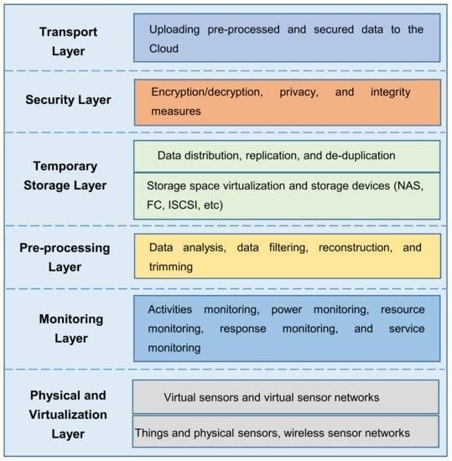
Figure 2. Layered architecture of fog computing.
The physical and virtualization layer involves different types of nodes such as physical nodes, virtual nodes and virtual sensor networks. These nodes are managed and maintained according to their types and service demands. Different types of sensors are distributed geographically to sense the surroundings and send the collected data to upper layers via gateways for further processing and filtering. While at the monitoring layer, resource utilization, the availability of sensors and fog nodes and network elements are monitored. All tasks performed by nodes are monitored in this layer, monitoring which node is performing what task, at what time and what will be required from it next. The performance and status of all applications and services deployed on the infrastructure are monitored. In addition, the energy consumption of fog nodes is monitored; since fog computing uses many devices with different levels of power consumption, energy management measures can be both timely and effective.
The pre-processing layer performs data management tasks. Collected data are analyzed and data filtering and trimming are carried out in this layer to extract meaningful information. The preprocessed data are then stored temporarily in the temporary storage layer. When the data are transmitted to the cloud, they no longer need to be stored locally and may be removed from the temporary storage media.
In the security layer, the encryption/decryption of data comes into play. In addition, integrity measures may be applied to the data to protect them from tampering. Finally, in the transport layer, the pre-processed data are uploaded to the cloud to allow the cloud to extract and create more useful services. For efficient power utilization, only a portion of collected data is uploaded to the cloud. In other words, the gateway device connecting the IoT to the cloud processes the data before sending them to the cloud. This type of gateway is called a smart gateway. Data collected from sensor networks and IoT devices are transferred through smart gateways to the cloud. The data received by the cloud is then stored and used to create services for users. Based on the limited resources of the fog, a communication protocol for fog computing needs to be efficient, lightweight and customizable. Therefore, choosing the communication protocol depends on the application scenario of the fog.
4. Fog Computing with IoT
The current centralized cloud computing architecture is facing severe challenges for IoT applications. For instance, it cannot support IoT time-sensitive applications such as video streaming, gaming and augmented reality.In addition, it lacks location awareness as it is a centralized model. Fog computing is able to address these challenges.
Fog computing acts as a bridge between IoT devices and large-scale cloud computing and storage services. According to Cisco, fog computing is a part of the cloud computing paradigm that takes the cloud closer to the edge of the network. It provides a highly virtualized model of computation, storage and networking resources between end devices and classical cloud servers.
To increase the efficiency of IoT applications, most of the data generated by these IoT objects/devices must be processed and analyzed in real-time.Fog computing will bring cloud networking, computing and storage capabilities down to the edge of the network, which will address the real-time issue of IoT devices and provide secure and efficient IoT applications.
Fog computing provides different services and applications with widely distributed deployments. The fog has the ability to provide efficient real-time communication between different IoT applications, such as connected vehicles, through the proxy and access points positioned according to long highways and tracks.
Fog computing is considered to be the best choice for applications with low latency requirements such as video streaming, gaming, augmented reality, etc.
The integration of fog computing with the IoT will bring many benefits to various IoT applications. The fog supports real-time interactions between IoT devices to reduce latency, especially for timesensitive IoT applications. In addition, one of the important features of fog computing is the ability to support large-scale sensor networks, which is a big problem with the ever-growing number of IoT devices, which will soon be counted in billions. Fog computing can provide many benefits to various IoT applications, as shown in Figure 3.
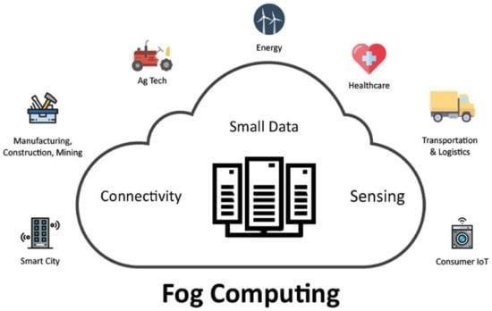
Figure 3. Fog computing supports many IoT applications to provide better service to customers.
Fog computing can provide effective ways to overcome many limitations of existing computing architectures that rely only on computing in the cloud and on end-user devices that are related to IoT devices.
Overview of the integration of the fog with the IoT. They started by discussing new issues in evolving IoT systems and how difficult it is to resolve these issues with current computing and networking models. The paper then discussed the necessity for a new architecture for computing, storage and networking and how this architecture can be used to create new business opportunities. The authors also discussed the characteristics of this fog architecture and its advantages and suggested solutions for some IoT challenges.
5. Applications of Fog with the IoT
- Connected Car
- Smart Traffic Lights
- Smart Home
- Wireless Sensor and Actuator Networks
- Healthcare and Activity Tracking
- IoT and Cyber–Physical Systems

6. Challenges of Fog with the IoT
Although the fog computing paradigm offers many benefits for different IoT applications, it faces many challenges that stand in the way of its successful deployment. These challenges include scalability, complexity, dynamicity, heterogeneity, latency and security, as shown in Figure 4.
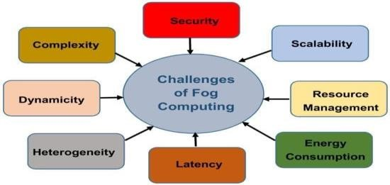
Figure 4. Challenges of fog computing.
- Scalability
- Complexity
- Dynamicity
- Heterogeneity
- Latency
- Security
- Resource management
- Energy consumption
- Open Issues of Fog with the IoT
It is obvious that fog computing is a new technology that needs more research to address all the challenges previously mentioned. This section provides an overview of open issues and future research directions related to fog computing and its integration with the IoT.
  - Communications between the Fog and the Cloud
Fog computing is an extension of the cloud, which is a central controller of fog servers that are deployed at different locations. The cloud manages the applications and contents of the entire system. In a fog, only selective localized applications are provisioned and synchronized with the cloud.
With the dual functions of the cloud, the data delivery and update from the cloud to fog faces problems related to communications sessions created during the processing of fog nodes. Selecting the appropriate communication between the fog and cloud that ensures high performance and low latency of fog nodes is a key challenge.
  - Communications between Fog Servers
Each fog server manages a pool of resources at different locations. Communication and collaboration between fog servers are necessary to maintain service provision and content delivery between them. If the communication efficiency is increased, the performance of the entire system will be improved.
The data transmission between fog servers faces many challenges that need to be addressed. For instance, there is a need for service policies where fog servers are deployed at different locations with different entities to enable them to adapt to different policies defined by owners. In addition, the data transmission between fog servers needs to consider connection features. In other words, fog servers need to be able to connect to each other using either wired or wireless connection over the Internet.
  - Fog Computing Deployment
Fog computing places additional computing and storage resources at the edge of the system to process local service requests quickly using local resources. As fog servers are deployed at different locations, they need to adapt their services regarding management and maintenance costs. In addition, the network operator of a fog computing system needs to address the requirements of each IoT application and fog server collaboration.
  - Parallel Computation Algorithm
Optimization algorithms are typically time and resource-consuming when applied on a large scale. Therefore, parallel approaches will be needed to accelerate the optimization process. Since fog computing provides computation resources to billions of IoT devices, using an efficient computation algorithm will be necessary to work with large-scale IoT applications.
Some current work provides potential results to leverage an in-memory computing framework to perform operations in a cloud infrastructure. However, building a system with dynamic graph generation and partitioning at runtime still needs more research, especially where the system has to adapt to dynamicity and a large number of IoT components.
  - Security
There are well-studied security issues for cloud computing that require significant security measures to protect the cloud. However, these measures are not suitable for fog computing due to its different characteristics, notably mobility, heterogeneity and large-scale geo-distribution. In addition, the fog is an appealing target for cyber-attackers since the fog contains large volumes of sensitive data from both the cloud and IoT devices. Therefore, more research is required to improve fog security.
  - End User Privacy
Preserving the end user’s privacy is a significant issue that faces fog computing as fog nodes are closer to end users, which allows them to collect more sensitive data including financial records, identity, usage of utilities, location and others. Furthermore, as fog nodes are distributed in large areas, maintaining centralized control is very difficult. Unsecured fog nodes can be the entry point for an attacker who can get into the network and steal user data that are exchanged among fog objects. Protecting the privacy of fog nodes is a challenging issue that requires more research.
Result:
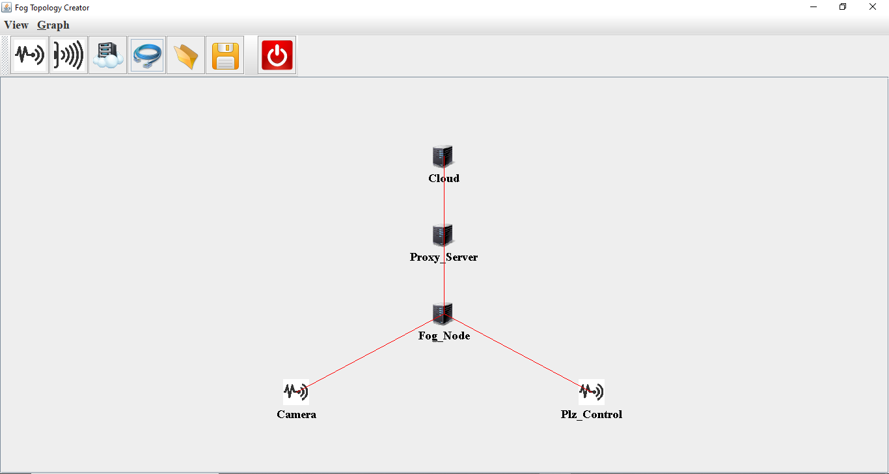
Conclusions:
Hence, we have successfully done with designing and deploying a fog computing architecture using simulators like iFogSim is a crucial step towards optimizing and enhancing the performance of real-world fog computing systems. This simulation-based approach offers several significant advantages, making it a valuable tool for research and development in the field of fog computing.

